**A JOURNEY THROUGH TIME: BIREUEN PENDOPO FROM PAST TO PRESENT**

**Kareem Abdul Wahid[1]**

|  |  |  |  |  |  |  |
| --- | --- | --- | --- | --- | --- | --- |
| |  |  |  | | --- | --- | --- | | **Article Info** |  | **Abstract** | | **Keywords:** Indonesia, historical buildings, Dutch colonial era, pendopo, Aceh Province, Bireuen Regency, cultural heritage, architecture, preservation, physical changes, historical tourism. |  | Indonesia boasts a rich heritage of historical buildings dating back to the Dutch colonial era, comprising diverse structures such as government buildings, hospitals, houses, tombs, monuments, schools, stations, factories, and airports. While some of these buildings remain intact, others have suffered damage or been lost over time. Among the preserved architectural wonders, the pendopo stands out, serving as office spaces, convention halls, or residences. Aceh Province in Indonesia is home to several such pendopo buildings, six of which remain intact and in use today. Preservation efforts focus on repairing fragile components, repainting, and replacing damaged materials while honoring the original design.  Bireuen Regency holds a unique place in history, its architectural influences tracing back to the colonial period. The Dutch government building, now known as the Bireuen Pendopo, has evolved from being a government establishment to serving as the residence of the Bireuen Regent. With ties to President Soekarno, who once used it as his temporary office during a visit, the Regent's Pendopo is a cultural and historical tourism site estimated to be over 70 years old, according to photo archives dating back to 1948.  This research delves into the evolution of the Bireuen Pendopo, analyzing its physical changes over three distinct periods: pre-independence (1934–1944), independence (1945–1998), and after the area expansion (1999–2021). By drawing from limited historical sources, the study aims to shed light on the building's past and its significance as a protected cultural heritage site. As a testament to the dynamic nature of architecture, the research explores how building functions, construction materials, environmental sustainability, and technological advancements have influenced the pendopo's transformation over time. | |

# 1. Introduction

Indonesia is one of the countries that has many historical buildings inherited from the Dutch during the colonial period. Historic buildings are spread throughout Indonesia, in the form of government buildings, hospitals, houses, tombs, monuments, schools, stations, factories, and airports. These buildings are either still intact, damaged, or lost. The buildings that are still intact are still being cared for and are used for office activities, residences, and other communal activities. One that is still used is a house building function as an office, convention hall, or residence called a *pendopo*. Aceh Province has several *pendopo* buildings in its area. There are six *pendopo* that are still intact and used. The maintenance of the *pendopo* is carried out by repairing parts that are already fragile, and painting and replacing damaged materials according to the original.

Bireuen Regency is an area whose buildings’ architecture was influenced by the colonial period. One of the historic buildings that are still used is the Dutch government building which is now used as the residence of the Bireuen Regent, known as the Bireuen *Pendopo*. After independence, the building was used as a residence, and when President Soekarno visited Bireuen, he stayed in the Pendopo and made it his temporary office.

Based on [1] and [2], the Regent's *Pendopo* as a cultural and historical tourism building is estimated to be more than 70 years old, judging by the photo archives when Ir. Soekarno visited Bireuen on 18 of June 1948. According to Drs. H. Hamdani Raden, as the first Regent of Bireuen Regency, the *Pendopo* became the official residence of the Deputy Regent at that time. The Pendopo has been in its original building that existed before independence and has not undergone significant changes. In contrast, according to Drs. H. Mustafa A. Glanggang, as the second Regent of Bireuen Regency, the Pendopo began to undergo significant changes in 2012.

Change is a process of transition or alteration in appearances such as form, nature and function. Physical change cannot occur directly but through various stages that are deliberately planned by each individual or group. According to [3], physical changes in architecture can not be separated from the influence of building functions that continue to develop, construction materials, sustainability with the surrounding environment, and technological developments. There are very few sources regarding the history and identification of the Bi-

reuen *Pendopo*. Meanwhile, the *Pendopo* is a protected cultural heritage building. The purpose of this study is to identify the physical changes of the Bireuen *Pendopo* from the pre-independence period (1934–1944), the independence period (1945–1998), and after the area expansion (1999–2021) and to obtain the documentation of the current *Pendopo.*

## 2. Literature Review

### **2.1. Physical Changes**

The book Transformation of the Site, [4] states that a built environment to be observed must have certain limits to be referred to as a site. At this stage, the observed site is only seen as a physical formation, without the behaviour or movement of the occupants. According to [5], the word transformation in Bahasa Indonesia can be equated with the word transfer, which means a change from the original object to the resultant object. Changes that occur can be categorized as changes that no longer show the similarity to the original object, as well as changes in which the resulting object still shows clues to the original object. According to [6] in his study of "Transformation in Javanese Architecture", transformation can be interpreted as making changes which include the form, external appearance, natural conditions or function, and transformation can also be interpreted as changing personal character. A site is formed from several elements, namely physical objects that have volume and can be moved/replaced, such as fences, houses, trees, etc. These elements are a solid part of a site. The existence and position of elements at a site shape the configuration of the site. The configuration of these elements forms the spaces between physical objects. These spaces constitute the void part of the site. The composition of physical objects and spaces within the site produces an arrangement of the site which ultimately forms a unity of the built environment to be observed.

In the built environment, there are various things about regulations that are not spoken of, such as customs, habits, and norms that apply to them. Different forms in a built environment are influenced by various explicit and implicit rules (customs and habits). To balance the two, there is a need for sustainable rule-making, agreement, and consensus among agents [7]. The building changes that occur can be divided into three parts, namely; (1) Core elements are elements that are slow to change and this becomes the identity of the architecture owner; (2) Peripheral elements are parts that are not too important and easy to change; (3) New elements are elements that are adapted by the owner of the culture and become a new part of the architecture [8].

Etymologically, change is a process of transition or alteration in appearances such as form, nature and function. According to [4] change is a process of changing shape that occurs gradually until it reaches the final stage due to the influence of external and internal factors that direct the change. Change is a process of changing shape in changing circumstances, so change is a process that occurs indefinitely [4]. According to [3]change in architecture cannot be separated from the influence of building functions that continue to develop, construction materials, sustainability with the surrounding environment, and technological developments. [4] Changes to elements or rules can be done by merging, balancing, or regrouping to maintain originality in creating new forms and meanings. According to [5] change is the result of human, organizations, groups or institution intervention that regulates the part where the change occurs. Change cannot occur directly but through various stages. Therefore, changing physical originality is power because each individual or group can decide on transferring, placing, reducing or adding an element. [6] and [7] describe the change process as follows: a. It takes place gradually or slowly.

1. It is comprehensive and sustainable.
2. It is a process that cannot be estimated in time, depending on factors that influence it.
3. It is related to the value system in society.
4. It is generally related to social factors.

According to [6] changes are categorized into 3 (three): (1). Fully transformation; the overall form of change, (2). Minor transformation; the form of changes that occur in several parts, and (3). Major transformation; the dominant form of change. According to [5], there are 3 (three) aspects that can be used as benchmarks in seeing changes: a. Spatial System,

A spatial system is the organization of space or related to space. This system covers space, spatial orientation and spatial relationship patterns.

b. Physical System

A physical system is related to the construction and materials used to construct the physical building. This system includes the structure and construction of the upper element (roof), middle element (body), and lower element (floor) of the building. c. Stylictic System

A Stylistic System is a system related to the style that embodies the form, such as the facade of the building.

There are three fundamentals in indicating a change to the physical building and the environment related to the space-forming elements in a site [8] and [5]. These include:

1. Addition: The addition of an element in a site so that changes occur. Such as a partition that creates a new space or a facade element in certain areas.
2. Reduction/Removal: A reduction or removal of an element in a site. Such as removing windows on the facade and changing the window model. It includes any changes that occur due to the reduction of elements in a part of the space.
3. Movement/Displacement: Changes caused by the movement or displacement of an element in the site. Such as moving the position of the door from one side to the other. It is part of the physical change of the building due to the movement.

According to Laseu (1980) in [4], the types of change are:

1. Geometrical formation that can change with the same elements and functions of space
2. Decorative change that can be done by reflecting, folding, and so forth
3. Opposite of the image of the object that is wanted to be transformed
4. Combination of the architect’s freedom in creativity

There are three change strategies according to [4]:

1. Traditional Strategy: It is a continuous change of form with gradual adaptation to the boundary of a. External: site, view direction, facing direction or orientation, wind direction, environmental standard b. Internal: program of space, function, and structural criteria c. Artistic: architect's skill, desire and way of manipulating form along with policies on funds and other criteria.
2. Borrowing Strategy: It is a change that can be categorized as a visual metaphor because it is a borrowing strategy from other forms such as paintings, sculptures and others.
3. Decomposition or Deconstruction Strategy: It is a process of an existing arrangement and then cracking it to find a new variety in combining it to create a new order and a new unity in a structural strategy that has a different composition.

## 2.2. Pendopo

The term Pendopo is derived from Mandapa which refers to a part of a Hindu temple in India. Mandapa means an outhouse or pavilion, a place where ceremonies with dances and music are held. In the arrangement of spaces in temple buildings in India, the mandapa (pendopo) is located in front of the sacred space called 'gartha griha', this space is the core. Therefore, the mandapa is equivalent to space, which in Indonesian-Hindu culture is known as the pendopo [14]; [15]

According to [9], *pendopo* is a public place which means all activities in it is related to other people or socialization. In principle, the *pendopo* is part of the house courtyard that is given a roof, a place for interaction between residents and visitors to the house, and must be open. Otherwise, the nature of *pendopo* as openness to the outside world has disappeared [10] . According to the experts' definition, the *pendopo* is the part of the house that is located at the front of the house and is a place to receive visitors. *Pendopo* is an open space that has a shade or roof and is airy.

### **2.3 History of Bireuen Pendopo**

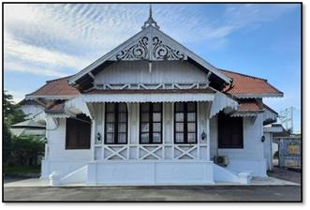

**Fig 1.** Bireuen *Pendopo* in 2021

Historically, Bireuen Regency has a reputation as “Kota Juang” or the City of Combat. The district had consistently been at the forefront of several war events in Aceh, and its people had been seen as more educated and open-minded[18]. At that time, the Indonesian people were facing Dutch military aggression. Thus, Bireuen was prepared as the third capital of the Republic of Indonesia, after the fall of Yogyakarta into Dutch rule, Jakorbi in [19], Bireuen is famous for its various heroic stories in historical records. According to H. A R Djoeli (Chairman of LVRI Bireuen Regency, 93 years old), on 19 of December 1948, during the military concentration of the X Division during the outbreak of the Second Aggression, Bireuen was nicknamed the "City of Combat" for defending the Republic of Indonesia from the attack of the Netherlands Second Aggression. Bireuen was also visited by the first President of the Republic of Indonesia during the conflict of Second Aggression, and the Bireuen *Pendopo* became the shelter for Ir. Soekarno for a week (based on the photo of Ir. Soekarno with the Bireuen fighters in 1948 and the certificate of "The President Sukarno Heritage List" in 2013). The Bireuen *Pendopo* is an old Dutch colonial heritage building. However, according to Hardiansyah (museum staff and preservation of the cultural heritage of Bireuen Regency) and Momo (Head of Subsection of Household and General Section of Bireuen Regional Secretariat), Bireuen *Pendopo* were built between 1902-1910 based on photo information they received from other parties.

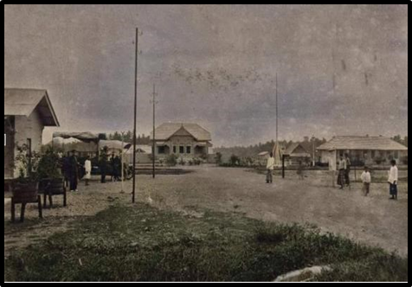

**Fig 2.** Bireuen *Pendopo* 1902-1913.

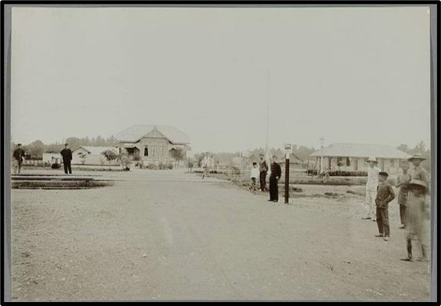

**Fig 3.** Bireuen Pendopo in 1913.

According to H. A R Djoeli (Chairman of LVRI Bireuen Regency), Bireuen Pendopo has become part of the government as an official residence since the colonial era. According to Narit (2009), the decision letter of the Vander Guevernement General van Nederland Indie dated 07 of September 1934 determined Bireuen Pendopo as the administrative centre for the Bireuen region. During the Old Order era in 1945, precisely on 19 of December 1948, when the Aceh military was centred in Bireuen, the Pendopo was used as the residence of the Commander-in-Chief Colonel Husein Joesoef with his family and the military headquarters of the X Division of the Sumatra Langkat Tanah Karo Command (Djoeli, 2013).

# 3. Methods

According to [20] descriptive qualitative method is a research method based on the philosophy of postpositivism used to examine the condition of natural objects (as opposed to experiments) where the researcher is the key instrument. The data collection technique is triangulation, the data analysis is inductive/qualitative, and the results of qualitative research emphasize meaning rather than generalization. The method used in this research is descriptive qualitative. This method analyzes data from various perspectives and compiles the results descriptively to get an overview of answers to research problems. Identification of physical changes in the Bireuen Pendopo was carried out by direct observation in the field, interviewing several sources and using documents and theoretical literature to analyze research results. Researchers pay attention to the physical changes in the *Pendopo* [6] regarding the category of changes through the physical variables of the building. The theory explains that the changes are categorized into three types; (1). Fully Transformation: a form of overall change in the *Pendopo* and changing the authenticity of the *Pendopo*, (2). Minor Transformation: Changes only occur in some parts of the *Pendopo*, (3). Major Transformation: Changes occur quite dominantly in some parts of the *Pendopo*. The scope of the research is limited to obtaining study results that follows the research objectives.

**Table 1.** The Scope of Research

|  |  |  |  |  |
| --- | --- | --- | --- | --- |
| Theory | Scope | Object | Parameter | Indicator |
|  |  |  |  | Roof |
|  |  |  |  | Wall |
| Changes according |  |  | Fully Transformation | Door |
| to Dewi and | Physical changes | *Pendopo* Bireuen | Minor Transformation | Window |
| Wakhidah (2013) |  |  | Major Transformation | Ventilation |
|  |  |  |  | Floor |

Foundation

## 4. Results and Discussion

Bireuen Regency is one of the cities known as the City of Combat because of the struggle to defend Indonesia's independence after the proclamation of independence on 17 of August 1945. The first President of Indonesia visited Bireuen City to ignite the people's spirit in fighting for the right to independence. This is evidenced by photo of Ir. Soekarno with the fighters in 1948 in the City of Bireuen.

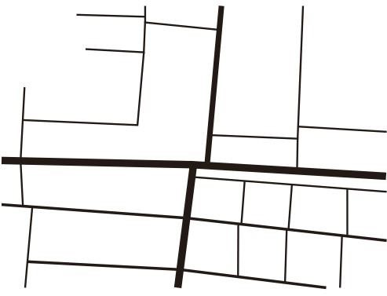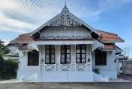

**Fig 4.** Bireuen Pendopo Location

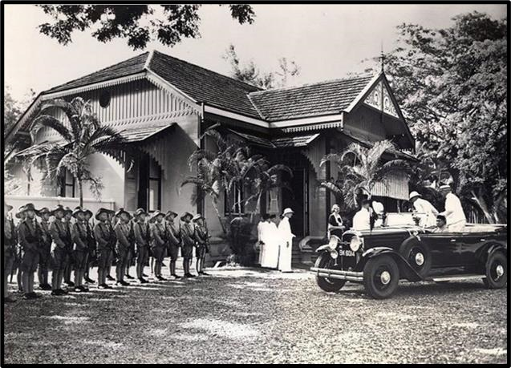

**Fig 5.** Bireuen Pendopo in 1935

**Table 2.** Bireuen *Pendopo* Before Independence (1934-1944)

### No. Physical Indicators of Bireuen Pendopo

1 Bireuen Pendopo Roof a. Roof Shape Saddle and shield on the side end of the roof

### b. Roof Material Shingle tile c. Roof Color Black d. Roof Structure Wooden Structure

2 Bireuen Pendopo Walls a. Wall Shape Wooden plank

### b. Wall Material Wood c. Wall Color White d. Wall Texture Horizontal stacking wooden planks

3 Bireuen Pendopo Door Door Type 1

|  |  |  |
| --- | --- | --- |
| a. | Door Number | 7 doors |
| b. | Door Shape | Rectangle (Vertical) with 2 doors |
| c. | Door Material | Wood and glass |
| d | Door Color | Dark brown and clear |
| .e. | Door Position | * 2 main doors, left and right of the front * 1 Rear door * 2 doors between rooms * 2 bedroom doors |
| f. Door Position  Door Type 2 | | 250 x (60 x 60) cm |
| a. Door Number | | 5 doors |
| b. Door Shape | | Rectangle (Vertical) with 2 leaf door |
| c. Door Material | | Wood |
| d Door Color | | Dark Brown |

.e. Door Position - 2 rear doors right and left

- 1 back door

### - 2 bedroom doors

f. Door size 250 x (60 x 60) cm Door Type 3

|  |  |
| --- | --- |
| a. Door Number | 2 doors |
| b. Door Shape | Rectangle (Vertical) with 1 leaf doors |
| c. Door Material | Wood |
| d. Door Color |  |
| e. Door Position | 2 connecting doors between bedrooms |
| f. Door Size | 250 x 80 cm |
| 4 | Bireuen *Pendopo* Window |
| Window Type 1 |  |
| a. Window Number | 3 windows |
| b. Window Shape | Rectangle (Vertical) |
| c. Window Material | Glass |
| d. Window Color | Clear |
| e. Window Position | *Pendopo* Facade |
| f. Window Size | 240 x (60 x 60) cm |

Window Type 2

|  |  |
| --- | --- |
| a. Window Number | 10 windows |
| b. Window Shape | Rectangle (Vertical) with 2 shutters |
| c. Window Material | Wood |
| d Window Color | Dark brown |
| .e. Window Position | Pendopo Exterior   * 2 windows on the left and right facade of the Pendopo * 4 windows on the left of the Pendopo * 4 windows on the right of the Pendopo |
| f. Window Size  Window Type 3 | 240 x (60 x 60) cm |
| a. Window Number | 10 windows |
| b. Window Shape | Rectangle (Vertical) with 2 shutters |
| c. Window Material | Glass |
| d Window Color | Clear |

.e. Window Position Pendopo Interiors

* 2 windows on the left and right facade of the Pendopo
* 4 windows on the left of the Pendopo
* 4 windows on the right of the Pendopo f. Window Size 240 x (60 x 60) cm

5 Bireuen Pendopo Ventilation Ventilation Type 1

|  |  |  |
| --- | --- | --- |
| a. | Ventilation Number | 11 |
| b. | Ventilation Shape | Rectangular (Horizontal) |
| c. | Ventilation Material | Glass |
| d | Ventilation Color | Clear |
| .e. | Ventilation Position | Above the door (except bedroom door) |
| f. | Ventilation Size | 120 x 60 cm |
|  |  | Bireuen Pendopo Floor |
| a. | Floor Shape | Flat |
| b. | Floor Material | Wood |
| c. | Floor Color | Brown |
| d | Floor Texture | Flat (Horizontal stacking boards) |
| . |  | Bireuen Pendopo Foundation |
| a. | Foundation Shape | Rectangular (Vertical) |
| b. | Foundation Material | Concrete |
| c. | Foundation Color |  |
| d . | Foundation Position | i. On the facade of the building ii. On the whole building foundation |
| e. | Foundation Structure | Pedestal foundation |

6

7

f.

Foundation Size

i.

4

2

x

4

2

x

1

2

0

cm ii.

4

2

x

4

2

x

7

5

cm

Source: Interview and Observation, 202

1

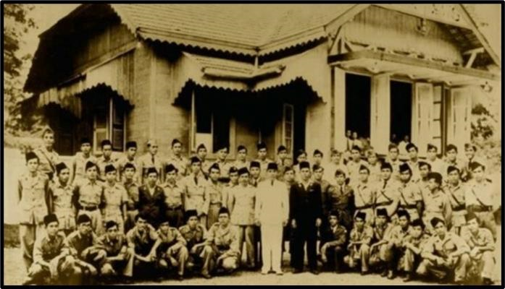

**Fig 6.** Bireuen *Pendopo* in 1948

**Table 3.** Bireuen Pendopo during the Independence Period (1945-1998)

No. Physical Indicators of Bireuen Pendopo

1 Bireuen Pendopo Roof

1. Roof Shape Saddle and shield on the side end of the roof
2. Roof Material Shingle tile

|  |  |  |
| --- | --- | --- |
| c. | Roof Color | Black |
| d | Roof Structure | Wooden Structure |

.

|  |  |  |
| --- | --- | --- |
|  |  | Bireuen Pendopo Wall |
| a. | Wall Shape | Wood Plank |
| b | Wall Material | Wood |
| c. | Wall Color | White |
| d | Wall Texture | Horizontal stacking wooden planks |

2

3 . Bireuen Pendopo Door

Door Type 1

|  |  |  |
| --- | --- | --- |
| a. Door Number | | 7 doors |
| b Door Shape | | Rectangle (Vertical) with 2 leaf doors |
| .c. Door Material | | Wood and glass |
| d Door Color | | Dark brown and clear |
| .e. Door Position | | * 2 main doors, left and right of the front * 1 rear door * 2 doors between rooms - 2 bedroom doors |
| f. Door size  Door Type 2 | | 250 x (60 x 60) cm |
| a. Door Number | | 5 doors |
| b Door Shape | | Rectangle (Vertical) with 2 leaf doors |
| c. Door Material | | Wood |
| d Door Color | | Dark Brown |
| .e. Door Position | | * 2 rear doors right and left * 1 back door * 2 bedroom doors |
| f. Door Size  Door Type 3 | | 250 x (60 x 60) cm |
| a. | Door Number | 2 doors |
| b | Door Shape | Rectangle (Vertical) with 1 leaf doors |
| .c. | Door Material | Wood |
| d | Door Color |  |
| .e. | Door Position | 2 connecting doors between bedrooms |
| f. | Door Size | 250 x 80 cm |

4 Bireuen Pendopo Window

Window Type 1

|  |  |
| --- | --- |
| a. Window Number | 3 windows |
| b Window Shape | Rectangle (Vertical) |
| .c. Window Material | Glass |
| d Window Color | Clear |
| .e. Window Position | Pendopo Facade |
| f. Window Size | 240 x (60 x 60) cm |
| Window Type 2 |  |
| a. Window Number | 10 windows |
| b Window Shape | Rectangle (Vertical) with 2 shutters |
| .c. Window Material | Wood |
| d Window Color | Dark brown |

.e. Window Position Pendopo Exterior

* + 2 windows on the left and right facade of the Pendopo
  + 4 windows on the left of the Pendopo
  + 4 windows on the right of the Pendopo f. Window Size 240 x (60 x 60) cm

Window Type 3

|  |  |  |
| --- | --- | --- |
| a. | Window Number | 10 windows |
| b | Window Shape | Rectangle (Vertical) with 2 shutters |
| .c. | Window Material | Glass |
| d | Window Color | Clear |

.e. Window Position Pendopo Interiors

* + 2 windows on the left and right facade of the Pendopo
  + 4 windows on the left of the Pendopo
  + 4 windows on the right of the Pendopo f. Window Size 240 x (60 x 60) cm 5 Bireuen Pendopo Ventilation

|  |  |  |
| --- | --- | --- |
| Ventilation | Type 1 |  |
| a. | Ventilation Number | 11 |
| b | Ventilation Shape | Rectangular (Horizontal) |
| .c. | Ventilation Material | Glass |

d

.

Ventilation Color

Clear

e. Ventilation Location Above the door (except bedroom door)

|  |  |  |
| --- | --- | --- |
| f. | Ventilation Size | 120 x 60 cm |
|  |  | Bireuen Pendopo Floor |
| a. | Floor Shape | Flat |
| b | Floor Material | Wood |
| .c. | Floor Color | Brown |
| d | Floor Texture | Flat (Horizontal stacking boards) |
| . |  | Bireuen Pendopo Foundation |
| a. | Foundation Shape | Rectangular (Vertical) |
| b | Foundation Material | Concrete |
| .c. | Foundation Color | - |
| d | Foundation Location | 1. On the facade of the building 2. On the whole building foundation |
| e. | Foundation Structure | Pedestal foundation |

6

7

f.

Foundation Size

i.

4

2

x

4

2

x

1

2

0

cm ii.

4

2

x

4

2

x

7

5

cm

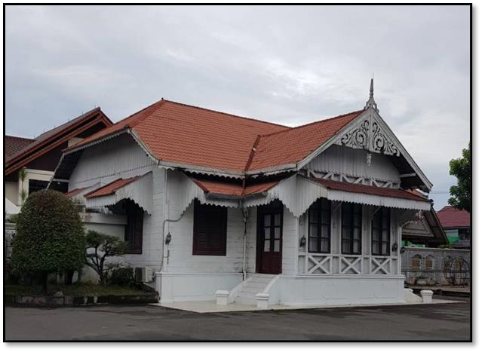

**Fig**

**7**

**.**

B

i

r

e

u

e

n

Pendopo

in

2

02

0

Source

:

The authors

**Table 4.** Bireuen *Pendopo* After Expansion (1999-2020)

N Physical Indicators of Bireuen Pendopo

o. 1 Bireuen Pendopo Roof

|  |  |  |
| --- | --- | --- |
| a. | Roof Shape | Saddle and shield on the side end of the roof |
| b | Roof Material | Shingle tile |
| .c. | Roof Color | Orange and Red |

d Roof Structure Wooden Structure

2 . Bireuen Pendopo Wall

|  |  |  |
| --- | --- | --- |
| a. | Wall Shape | Wood and concrete wall |
| b | Wall Material | Wood and concrete |
| .c. | Wall Color | White |

d Wall Texture Horizontal stacking wooden dan concrete wall

3 . Bireuen Pendopo Door

Door Type 1

|  |  |  |
| --- | --- | --- |
| a. | Door Number | 8 doors |
| b. | Door Shape | Rectangle (Vertical) with 2 leaf doors |
| c. | Door Material | Wood and glass |
| d | Door Color | Dark brown (exterior) Light gray (interior) |

.e. Door Position - 2 main doors, left and right of the front

* 1 rear door
* 2 doors between rooms
* 2 bedroom doors

### - 1 banquet room door

f. Door Size 250 x (60 x 60) cm

Door Type 2

|  |  |  |
| --- | --- | --- |
| a. | Door Number | 5 doors |
| b | Door Shape | Rectangle (Vertical) with 2 leaf doors |

.c. Door Material Wood

1. Door Color Dark brown and white (exterior) Light gray (interior)
2. Door Position - 2 rear doors right and left

- 1 back door

### - 2 bedroom doors

f. Door Size 250 x (60 x 60) cm

Door Type 2

|  |  |  |
| --- | --- | --- |
| a. | Door Number | 2 doors |
| b. | Door Shape | Rectangle (Vertical) with 1 leaf door |
| c. | Door Material | Wood |
| d | Door Color | Light gray |
| .e. | Door Position | 2 connecting doors between bedrooms |
| f. | Door Size | 250 x 80 cm |
| Door Type 3 | |  |
| a. | Door Number | 4 doors |
| b. | Door Shape | Rectangle (Vertical) with 1 leaf door |
| c. | Door Material | Aluminum Metal |
| d | Door Color | Silver |
| .e. | Door Position | The bathroom door in the room |
| f. | Door Size | 200 x 70 cm |

4 Bireuen Pendopo Window

Window Type 1

|  |  |
| --- | --- |
| a. Window Number | 3 |
| b. Window Shape | Rectangle (Vertical) |
| c. Window Material | Glass |
| d Window Color | Clear |
| .e. Window Position | Pendopo Facade |
| f. Window Size | 240 x (60 x 60) cm |
| Window Type 2 |  |
| a. Window Number | 10 pintu |
| b. Window Shape | Rectangle (Vertical) with 2 shutters |
| c. Window Material | Wood |
| d Window Color | Brown |

.e. Window Position Pendopo Exterior

* 2 windows on the left and right facade of the Pendopo
* 4 windows on the left of the Pendopo

### - 4 windows on the right of the Pendopo

f. Window Size 240 x (60 x 60) cm

Window Type 3

|  |  |  |
| --- | --- | --- |
| a. | Window Number | 10 windows |
| b. | Window Shape | Rectangle (Vertical) with 2 shutters |
| c. | Window Material | Glass |
| d | Window Color | Clear |

.e. Window Position Pendopo Interior

* 2 windows on the left and right facade of the Pendopo
* 4 windows on the left of the Pendopo

### - 4 windows on the right of the Pendopo

f. Window Size 240 x (60 x 60) cm

5 Bireuen Pendopo Ventilation

Ventilation Type 1

|  |  |
| --- | --- |
| a. Ventilation Number | 11 |
| b. Ventilation Shape | Rectangular (Horizontal) |
| c. Ventilation Material | Glass |
| d Ventilation Color | Clear |
| .e.  Ventilation Location | Above the door (except bedroom door) |
| f. Ventilation Size | 120 x 60 cm |
| Ventilation Type 2 |  |
| a. Ventilation Number | 6 |
| b. Ventilation Shape | Rectangular (Horizontal) |
| c. Ventilation Material | Glass |
| d Ventilation Color | Clear |

|  |  |  |
| --- | --- | --- |
| e. | Ventilation Position | 2 ventilations in each bathroom on the left side of the building  1 ventilation for each bathroom on the right side of the building |
| f. | Ventilation Size | 30 x 55 cm |
|  |  | Bireuen Pendopo Floor |
| a. | Floor Shape | Flat |
| b. | Floor Material | Wood and red carpet |
| c. | Floor Color | Red |
| d | Floor Texture | Flat |
| . |  | Bireuen Pendopo Foundation |
| a. | Foundation Shape | Rectangular (Vertical) |
| b. | Foundation Material | Concrete |
| c. | Foundation Color | White |
| d | Foundation Location | 1. On the facade of the building 2. On the whole building foundation |
| e. | Foundation Structure | Pedestal foundation |

6

7

f. Foundation Size

i. 42 x 42 x 120 cm

ii. 42 x 42 x 75 cm

According to interviews with informants and direct observations, before independence (1934-1944) the roof of the Bireuen Pendopo did not undergo any form of change. During the independence period (1945-1998), the Bireuen Pendopo roof also did not undergo a change in form but underwent a slight addition of a new roof in the bathroom. After the expansion (1999-2020), the Bireuen Pendopo roof underwent a major transformation due to the occurrence of several changes to the roof material and construction which also affects the physical changes and other conditions of the Bireuen Pendopo.

**Table 5.** Categories of Changes in the Bireuen Pendopo Roof

**Roof**

**Changes**

**Note**

**Fully Transformation** **Minor Transformation** **Major Transformation**

|  |  |  |  |  |
| --- | --- | --- | --- | --- |
| (1934-1944) | Changes to the roof as a whole so it is difficult to find the original roof of the building | Changes are only in some parts of the roof and do not affect other physical  changes of the building | There are many changes to the roof (quite dominant) so that it changes the other physical properties of the building and its surroundings | No changes. |
| (1945-1998) | Changes to the roof as a whole so it is difficult to find the original roof of the building | Changes are only in some parts of the roof and do not affect other physical  changes of the building | There are many changes to  the roof (quite dominant) so that it changes the other physical properties of the building and its surroundings | Slight changes |
| (1999-2020) | Changes to the roof as a whole so it is difficult to find the original roof of the building | Changes are only in some parts of the roof and do not affect other physical  changes of the building | There are many changes to the roof (quite dominant) so that it changes the other physical properties of the building and its surroundings | Changes |

According to the results of interviews with several sources and direct observations in the field, the walls of the Bireuen *Pendopo* before independence (1934-1944) did not undergo any form of change. During the independence period (1945-1998), the walls of the Bireuen *Pendopo* underwent a minor transformation due to wall painting and the addition of a bathroom but did not change the originality of the walls of the building. After the expansion (1999-2020), the walls of the Bireuen *Pendopo* underwent a major transformation due to several changes to the colouring (puttying) of the building walls, the breaking of the walls and the addition of walls

which affected the physical changes and other conditions of the Bireuen *Pendopo*.

**Table 6.** Categories of Changes in the Bireuen Pendopo Wall

**Changes**

**Wall** **Note**

|  |  |  |  |  |
| --- | --- | --- | --- | --- |
| (1934-1944) | Changes to the walls as a whole so that it is difficult to find the original walls of the building | Changes are only in some parts of the walls and do not affect other physical changes of the building | There are many changes to the walls (quite dominant) so that it changes the other physical properties of the building and its surroundings | No changes. |

***Fully***

|  |  |  |  |  |
| --- | --- | --- | --- | --- |
| (1945-1998) | Changes to the walls as a whole so that it is difficult to find the original walls of the building | Changes are only in some parts of the walls and do not affect other physical changes of the building | There are many changes to the walls (quite dominant) so that it changes the other physical properties of the building and its surroundings | Changes |
| (1999-2020) | Changes to the walls as a whole so that it is difficult to find the original walls of the building | Changes are only in some parts of the walls and do not affect other physical changes of the building | There are many changes to the walls (quite dominant) so that it changes the other physical properties of the building and its surroundings | Changes |

***Transformation*** ***Minor Transformation*** ***Major Tranformation***

Source: Author’s analysis, 2021

## 5. Conclusion

Based on the results of the research on the study of physical changes that have been carried out on the Bireuen Pendopo, it is concluded that before independence (1934-1944), it did not undergo any form of physical change. During the independence period (1945-1998), it underwent a minor transformation. While after the area expansion when Bireuen became a regency (1999-2021), Bireuen Pendopo has undergone minor transformation, major transformation and fully transformation.

The physical changes of the Bireuen Pendopo in the three periods were categorized based on the changes. Before independence (19341944), it did not undergo any form of change and was the original form of the Bireuen Pendopo. During the independence period

(1945-1998), it underwent minor transformations on walls, doors, windows, and ventilation. While after the area expansion (19992021), the changes that occurred in the Bireuen Pendopo were minor transformations on doors, windows, and ventilation, major transformation on roofs, walls and floors and fully transformation on the foundation of Bireuen Pendopo.

## Acknowledgement

We would like to thank the Architectural Study Program, Faculty of Engineering, Malikussaleh University who has provided support in completing this research and Drs. H. Hamdani Raden and Mustafa Geulanggang who have provided data, input and documentation of the Bireuen Pendopo.

**References**

Pemerintah Kabupaten Bireuen, Qanun Kabupaten Bireuen Nomor 10 Tahun 2014 Tentang Gedung. Indonesia, 2014.

Pemerintah Kabupaten Bireuen, Qanun Kabupaten Bireuen Nomor 7 Tahun 2013 Tentang Rencana Tata Ruang Wilayah Kabupaten Bireuen Tahun 2012-2032. Indonesia, 2013.

G. Faisal and Y. Firzal, “Transformasi Identitas Arsitektur Vernakular Pesisir Tinjauan Kasus Permukiman Suku Akit Di Pulau Rupat,” Proseding Semin. Kearifan Lokal Dan Lingkung. Binaan, no. May, pp. 455–464, 2017, [Online]. Available: https://www.researchgate.net/publication/316682366.

N. J. Habraken, Transformations of the Site. Awater Press, 1983.

J. Prijotomo, “(Re- )konstruksi arsitektur Jawa : griya Jawa dalam tradisi tanpatulisan,” p. 440, 2006, [Online]. Available:http://www.worldcat.org/title/re-konstruksi-arsitektur-jawa-griya-jawa-dalam-tradisitanpatulisan/oclc/196260650&referer=brief_results.

G. Susilo, “Ransformasi Bentuk Arsitektur Jawa,” Spectra, vol. XIII, no. 25, pp. 13–26, 2015.

M. Sesotyaningtyas, W. D. Pratiwi, and J. S. Setyono, “Transformasi Hunian Dengan Perspektif Spasial Dan Tatanan Budaya:

Komparasi Permukiman Kumuh Bang Bua, Thailand Dan Kampung Naga, Indonesia,” Geoplanning J. Geomatics Plan., vol. 2, no. 2, pp. 116–123, 2015, doi: 10.14710/geoplanning.2.2.116-123.

A. Rapoport, “The Evidence,” in History and Precedent in Environmental Design, Springer, 1990, pp. 297–311.

S. J. Najoan and J. Mandey, “Transformasi Sebagai Strategi Desain,” Media Matrasain, vol. 8, no. 1, pp. 29–39, 2011, [Online]. Available: https://core.ac.uk/download/pdf/295355498.pdf.

Luthfiah, “Perubahan bentuk dan fungsi hunian pada rumah susun pasca penghunian,” J. Ruang, vol. 2, no. September, p. 221026, 2010, [Online]. Available: http://jurnal.untad.ac.id/jurnal/index.php/RUANG/article/view/728.

W. Kurniawati, N. Nurini, D. I. K. Dewi, and R. R. B. Rahmat, “Identifikasi Transformasi Fisik Berdasarkan House Extension di Kampung Sekayu Kota Semarang,” J. Planol., vol. 17, no. 1, p. 1, 2020, doi: 10.30659/jpsa.v17i1.7555.

I. S. Susanti, N. I. Komala Dewi, and A. Y. Permana, “Tatanan Teritorial dalam Proses Transformasi Hunian,” J. Arsit. Zo., vol. 1, no. 1, p. 27, 2018, doi: 10.17509/jaz.v1i1.11542.

E. Durmisevic, “Transformable Building Structures,” Delft Univ. Technol., p. 42, 2006, [Online]. Available: http://resolver.tudelft.nl/uuid:9d2406e5-0cce-4788-8ee0-c19cbf38ea9a.

Y. B. Mangunwijaya, “Wastu citra: Pengantar ke ilmu budaya bentuk arsitektur,” Jakarta: Gramedia Pustaka Utama, 1992.

D. Sumintardja, “Kompedium Arsitektur Indonesia,” Parahiyangan Bandung, 1981.

Maria I Hidayatun, “PENDOPO DALAM ERA MODERNISASI : Bentuk Fungsi dan Makna Pendopo pada Arsitektur Tradisional Jawa dalam Perubahan Kebudayaan,” Dimens. (Jurnal Tek. Arsitektur), vol. 27, no. 1, 1999, [Online]. Available: http://puslit2.petra.ac.id/ejournal/index.php/ars/article/view/15706.

A. S. Muljadinata, “Penerapan Konsep Tradisional Pendopo Bangunan SMA Van Deventer Karya Seminar Nasional Jelajah Arsi-

tektur Tradisional 2017 Penerapan Konsep Tradisional Pendopo Bangunan SMA Van Deventer Karya Karsten,” no. September, 2017.

S. Marhaban, “Women in Post-conflict Aceh: Participation in Socio-economic and Political Processes,” Weather. Cent. Int. Aff. Harvard Univ. Cambridge, no. March, pp. 25–27, 2018.

R. Jannah, “Perjuangan Masyarakat Bireuen Pada Masa Revolusi Kemerdekaan (1945-1949),” Thisis. Unsam, 2017. [20] Prof. Dr. Sugiyono, Metode Penelitian Kuantitatif Kualitatif dan R & D. Bandung: CV. Alfabeta, 2011.

1. College of Architecture Art and Design, Ajman University, United Arab Emirates